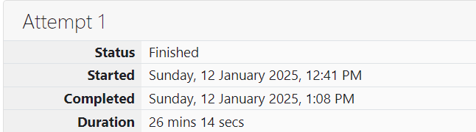

ROLL NO.: 241801281

NAME: SUJITHA NEELAKANDAN VIGNESHWARI

WEEK 10-1

1.OBJECTIVE:

Given a string, s, consisting of alphabets and digits, find the frequency of each digit in the given string

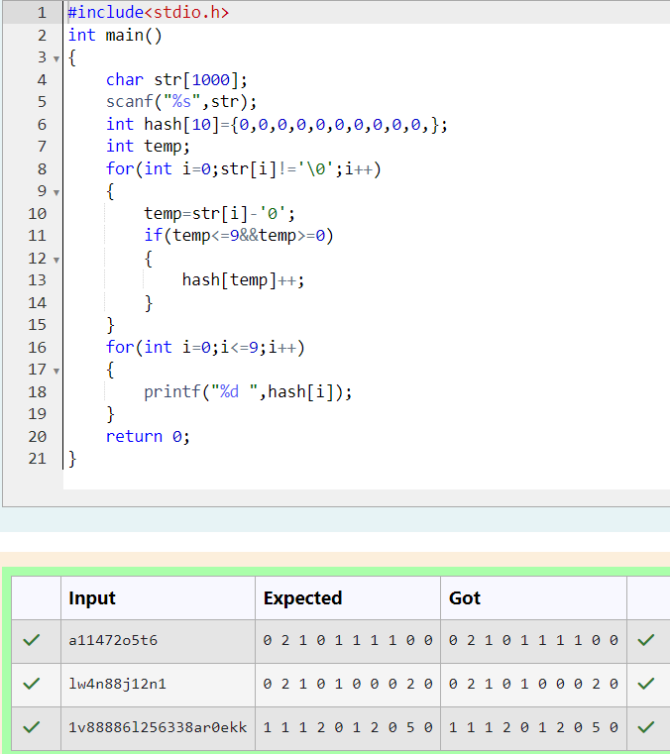CODE:

2.OBJECTIVE:

Today, Monk went for a walk in a garden. There are many trees in the garden and each tree has an English alphabet on it. While Monk was walking, he noticed that all trees with vowels on it are not in good state. He decided to take care of them. So, he asked you to tell him the count of such trees in the garden.

CODE:

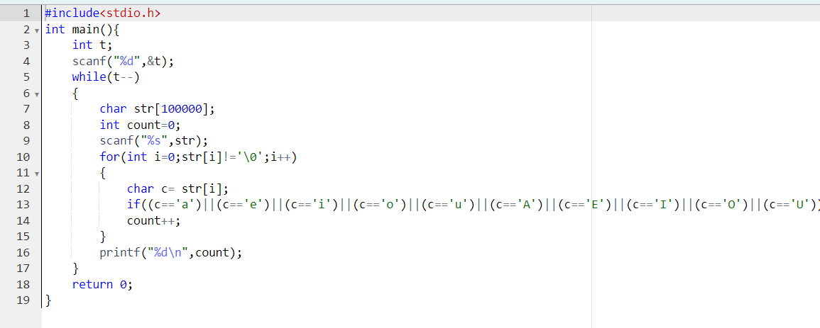

OUTPUT:

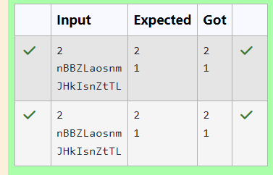

3.OBJECTIVE:

Given a sentence, s, print each word of the sentence in a new line.

CODE:

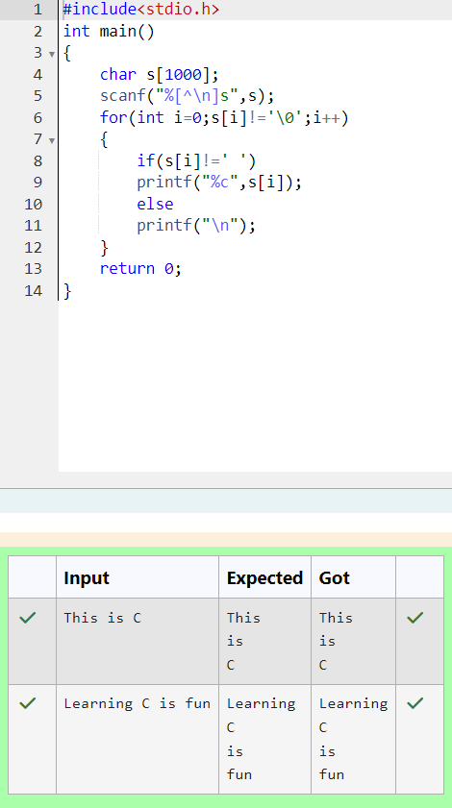

4.OBJECTIVE:

You are given two strings, a and b, separated by a new line. Each string will consist of lower case Latin characters ('a'- 'z').

CODE:

